Internship Report
On
Image Recognition System Using Machine Learning Classification Techniques
Submitted
To
School of Computer Science and Engineering
IILM University, Greater Noida, U.P.
In partial fulfilment of the requirement of degree of
B.Tech CSE

By
Roll Number of Student: 25SCS1003004241
Name of Student: YASH DIXIT
Batch: 2026-27

CANDIDATE'S DECLARATION
I, YASH DIXIT, Roll Number 25SCS1003004241, do hereby declare that the internship report titled “Image Recognition System Using Machine Learning Classification Techniques” has been completed by me to fulfil the requirement for the award of the degree of Bachelor of Technology in CSE. All the references have been quoted and I have not taken as such any material from any other source. I affirm to you that this report is my own and has not been submitted to any other institute for any degree/diploma requirement and further I shall be solely responsible for any kind of copyright violation in this regard.

Signature: 
Student Name: YASH DIXIT
Roll No.: 25SCS1003004241

ACKNOWLEDGEMENT
I am using this opportunity to express my gratitude to everyone who supported me throughout the Internship Program. I am thankful for their aspiring guidance, invaluably constructive criticism and friendly advice during this work. I am sincerely grateful to them for sharing their truthful and illuminating views on a number of issues related to this work.
I would like to sincerely thank Codec Technologies Pvt. Ltd. and my internship mentors for giving me the opportunity to work on the “Image Recognition System” project under the AICTE & ICAC approved internship program, and for their continuous support and guidance throughout the duration of the internship.
I would also like to thank the School of Computer Science and Engineering, IILM University, Greater Noida, for providing me the platform and encouragement to undertake this internship as part of my B.Tech CSE curriculum.
I express my gratitude to my parents for their blessings.

Signature:
Student Name: YASH DIXIT
Roll No.: 25SCS1003004241

TABLE OF CONTENTS
Chapter No. | Chapter Name | Page Nos.
 | Cover Page | —
1. | Candidate's Declaration | i
2. | Acknowledgement | ii
3. | Table of Contents | iii
4. | Internship Completion Certificate | —
5. | Project Description | 1
 | 5.1 Introduction | 1
 | 5.2 Organization Profile | 1
 | 5.3 Problem Statement | 1
 | 5.4 Project Objectives | 2
 | 5.5 Scope of the Project | 2
 | 5.6 Technologies and Tools Used | 2
 | 5.7 System Architecture | 3
 | 5.8 Methodology | 3
 | 5.9 Expected Outcomes | 4
 | 5.10 Certificate of Completion and Communication Proof | 4
6. | Bibliography/References | 5

INTERNSHIP COMPLETION CERTIFICATE
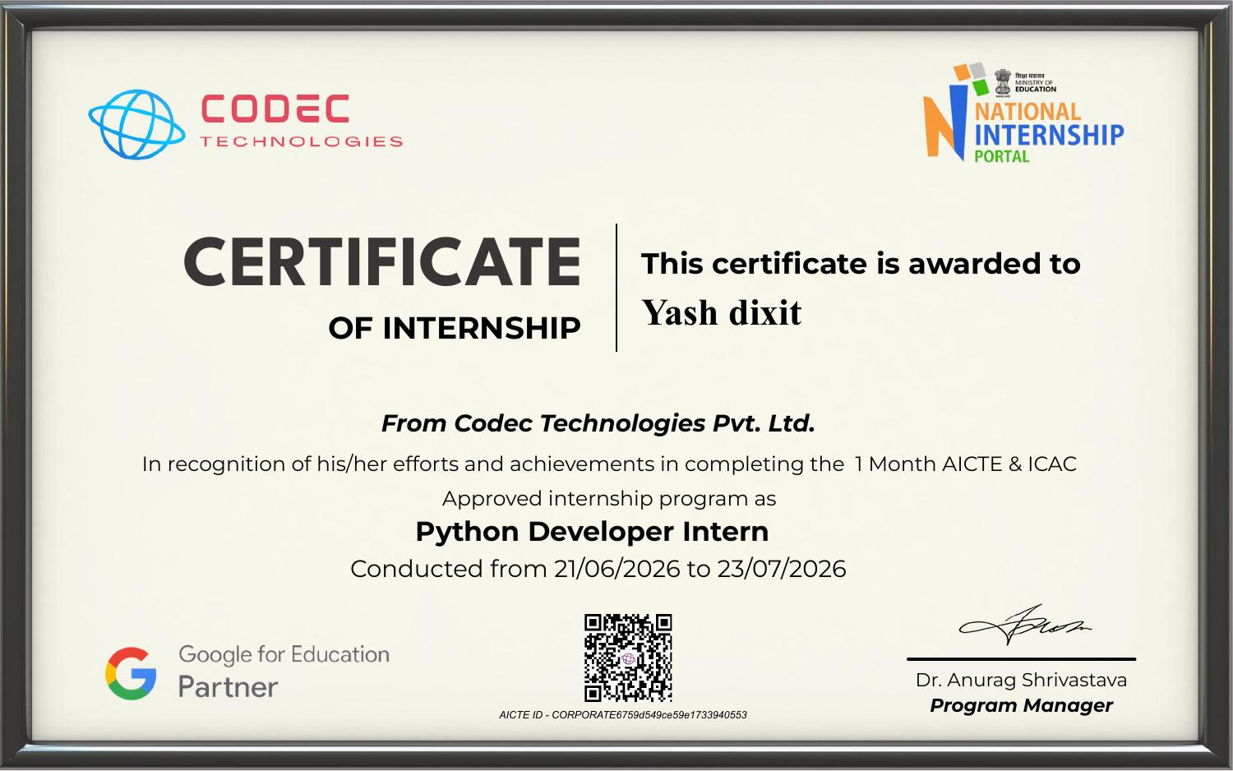

5. Project Description

5.1 Introduction
Artificial Intelligence (AI) and Machine Learning (ML) have become central to how modern software systems interpret and act upon visual data. As part of my one-month internship in the field of Artificial Intelligence at Codec Technologies Pvt. Ltd., conducted under the AICTE & ICAC approved internship program from 21/06/2026 to 23/07/2026, I worked on the design and development of an Image Recognition System. The internship provided hands-on exposure to Python-based development, image processing, feature extraction and classical machine learning techniques used for classifying images based on their visual characteristics.
The project undertaken was titled “Image Recognition System Classifier”, and its objective was to build a system capable of identifying and classifying images into predefined categories using supervised machine learning algorithms, specifically Naive Bayes and Support Vector Machines (SVM). This report documents the organization profile, problem statement, objectives, scope, tools used, system architecture, methodology and outcomes of the project.

5.2 Organization Profile
Codec Technologies Pvt. Ltd. is a technology-focused organization that runs industry-oriented internship programs in collaboration with the National Internship Portal, under AICTE and ICAC approval, and in partnership with Google for Education. The organization focuses on providing students with practical, project-based learning experiences in domains such as Artificial Intelligence, Machine Learning, Python development, and Data Science, enabling interns to translate classroom concepts into real, working software solutions.
During the internship, I was assigned the role associated with Python-based AI development, where I worked under the guidance of the program's technical mentors to complete a structured, milestone-driven project within the one-month duration of the program.

5.3 Problem Statement
Manual identification and categorization of images is time-consuming, inconsistent, and does not scale well when the volume of image data grows. Many real-world applications — including quality inspection, document sorting, medical imaging support, and object cataloguing — require an automated system that can look at an image and correctly determine which category it belongs to, based on its visual features such as colour, shape, texture and edges.
The problem addressed in this project was: how can we design a system that automatically extracts meaningful visual features from images and uses a machine learning model to classify those images accurately and consistently, without manual intervention?

5.4 Project Objectives
- To develop an Image Recognition System using Python capable of identifying and classifying images based on their visual features.
- To preprocess raw image data (resizing, normalization, noise removal) to prepare it for feature extraction.
- To extract relevant visual features from images using computer vision techniques.
- To train a machine learning model — using Naive Bayes and Support Vector Machine (SVM) algorithms — to classify images into their correct categories.
- To evaluate and compare the performance of the trained classifiers using standard accuracy metrics.
- To gain practical experience in applying AI/ML concepts to a real, end-to-end image classification pipeline.

5.5 Scope of the Project
The scope of this project is limited to building a classical machine learning-based image classification pipeline rather than a deep learning system. It covers image acquisition, preprocessing, feature extraction, model training and evaluation for a defined set of image categories. The system is designed as a learning-oriented prototype suitable for demonstrating the complete workflow of an image recognition pipeline, and can be extended in the future with deep learning architectures such as Convolutional Neural Networks (CNNs) for higher accuracy on larger and more complex datasets.

5.6 Technologies and Tools Used
- Programming Language: Python
- Libraries: NumPy, Pandas, Matplotlib, Scikit-learn
- Image Processing: OpenCV, Pillow (PIL)
- Machine Learning Algorithms: Naive Bayes, Support Vector Machine (SVM)
- Development Environment: Jupyter Notebook / Google Colab
- Version Control: Git and GitHub

5.7 System Architecture
The system follows a linear pipeline architecture consisting of the following stages:
- Image Input Layer: Collects raw images from the dataset.
- Preprocessing Layer: Resizes, normalizes and denoises the images to ensure uniformity.
- Feature Extraction Layer: Extracts visual features such as colour histograms, edge and texture descriptors from each image.
- Classification Layer: Feeds the extracted feature vectors into the trained Naive Bayes / SVM classifier.
- Output Layer: Displays the predicted class label for each input image along with the model's confidence/accuracy.
This modular architecture allowed each stage of the pipeline to be developed, tested, and debugged independently before being integrated into the final system.

5.8 Methodology
- Data Collection: Gathered a labelled image dataset covering the target classes for classification.
- Image Preprocessing: Resized all images to a fixed dimension, converted them to a consistent colour format, and normalized pixel values.
- Feature Extraction: Applied computer vision techniques to extract discriminative features (colour, texture and shape-based descriptors) from each preprocessed image.
- Train-Test Split: Divided the dataset into training and testing subsets to allow unbiased evaluation of the model.
- Model Training: Trained a Naive Bayes classifier and a Support Vector Machine (SVM) classifier on the extracted feature vectors using Scikit-learn.
- Model Evaluation: Evaluated both classifiers on the test set using accuracy, precision, recall and confusion matrices, and compared their performance.
- Result Analysis: Analysed misclassifications to understand the limitations of classical feature-based classification, and documented possible improvements.

5.9 Expected Outcomes
- A working Python-based Image Recognition System capable of classifying images into the correct categories.
- Comparative performance results between the Naive Bayes and SVM classifiers on the same dataset.
- A clear, documented understanding of the complete image classification pipeline — from raw image to predicted label.
- Practical, hands-on experience with image preprocessing, feature extraction and classical machine learning techniques in Python.
- A reusable codebase that can later be extended with deep learning-based approaches such as CNNs for improved accuracy.

5.10 Certificate of Completion and Communication Proof
A copy of the Internship Completion Certificate issued by Codec Technologies Pvt. Ltd., verifying the successful completion of the one-month AICTE & ICAC approved internship program in the role of Python Developer Intern (Artificial Intelligence track) from 21/06/2026 to 23/07/2026, has been attached in Chapter 4 of this report.

6. Bibliography/References
[1] Scikit-learn Developers, “Scikit-learn: Machine Learning in Python,” Scikit-learn Documentation. [Online]. Available: https://scikit-learn.org
[2] OpenCV Team, “OpenCV: Open Source Computer Vision Library Documentation.” [Online]. Available: https://opencv.org
[3] NumPy Developers, “NumPy Documentation.” [Online]. Available: https://numpy.org
[4] Python Software Foundation, “Python Language Reference.” [Online]. Available: https://www.python.org
[5] Codec Technologies Pvt. Ltd., “AICTE & ICAC Approved Internship Program – Program Guidelines,” National Internship Portal.
[6] R. Duda, P. Hart, and D. Stork, Pattern Classification, 2nd ed. Wiley-Interscience, 2000.
[7] C. Cortes and V. Vapnik, “Support-Vector Networks,” Machine Learning, vol. 20, pp. 273–297, 1995.

